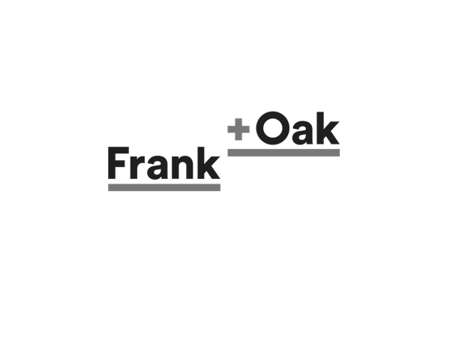A Customer Reflection

## By: Alexandra Findlay

## Frank and Oak

Frank & Oak is a Canadian menswear brand with a brick-and-mortar location in Montreal. Even though they have had their home base out of Montreal since 2012, they have created a cult fan base nationally with their unique loyalty program. This program allows us as the customer to feel special to the company as they send a monthly individualized assortment of new clothes, which we get to try on, decide what we like, and send back the rest. They are a perfect example of identifying a problem many men seem to face in their quest to remain fashionable which is their lack of time and enjoyment in the shopping process. With other brands slowly seeing the merit of their specialized programs, Frank & Oak has managed to remain ahead of the game through all their unique touch points and uniform designs across all channels.

## The Customer

I can argue that Frank & Oak is aiming to do more than one “job” for its customers. They look to perform a functional job, as many of their customers spend their days running around, and therefore so a time saving option is ideal for them. Additionally, they aim to perform a social job for their customers by keeping them looking on trend. Individuals, traditionally men, find that going shopping in person is too time consuming yet many people are wary of online shopping as they are unsure of fit, return policies, etc. When I shop online, my biggest concern is that the clothes will not look as trendy on me as they may look on the online model. These pains leave certain gaps in the customer experience design. When shopping however, no matter what channel we use, all we want at the end of the experience is to look good, be recognized for our “trendiness” in social settings, and to feel good about the interactions and experiences that we had throughout the process. Additionally, shoppers may want a surprising twist that meets these needs but may be outside their traditional shopping experiences. A surprise element to the shopping always adds to the experience which Frank & Oak do have.

## Customer Journey Map

To better understand the customer experience for Frank & Oak, I have created a modified customer journey map. I have included the general expectations a customer expects from Frank & Oak both on their online presence (a) and their in store presence (b). By having a CJM that maps both experiences, it is easier to identify expected and unexpected weaknesses in the customer experience.

The majority of the customer expectation is pretty high as I view Frank & Oak as a company that has met and exceeded the expectations of my age demographic by anticipating our needs before we realized we had them. Where they drop below average is in their in in-store presence as they have set such a high expectation with their online presence. Additionally, after purchase, the individual attention does not continue to such a high degree as it does before purchase. All of these outcomes/ expectations are portrayed in the figure below.

## Figure 1: Customer Journey Map

6

1

Great

7b

3a

4

5

7a

8

3b

2

Poor

Plan to shop Arrive Shop Pay & Leave

(virtually or in store)

1. Search Internet 2) Pre- sale support 3a) Load App or website 3b)Park 4) Enter store/app 5) Choose clothes 6) Checkout 7a) Leave app/website 7b) Leave location 8) Follow up

## Channels

Frank & Oak have three primary channels they work with. These are their website, their app, and their brick- and- mortar locations. These 3 pieces come together to make a holistic, seamless service to meet the needs of their target customers and to revolutionize the way the fast fashion industry in Canada works.

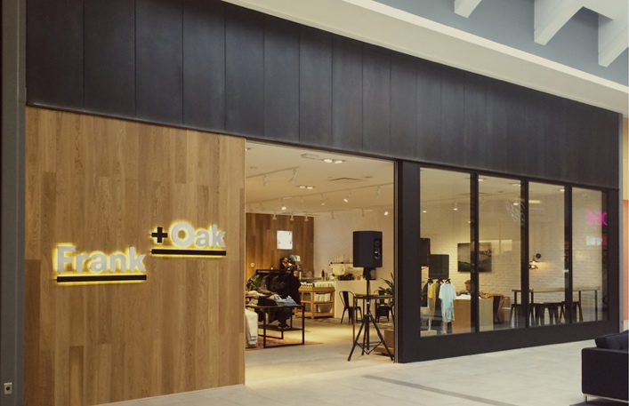The first point of contact and channel of Frank & Oak is their brick- and- mortar location. Originally from Montreal, they opened their first location in 2012. Laid out in a modern, but not necessarily original way, they inserted a “wow” factor through the services they offered in- store. They crafted themselves as a one stop style shop by including a barber shop at the location. Now with two locations, they make the shopping experience that much more time efficient for the individuals.

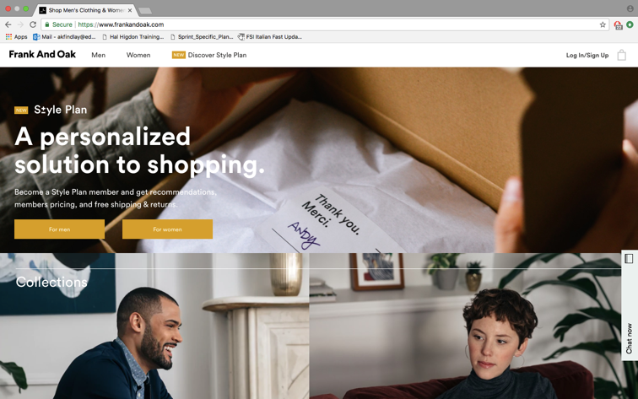The second channel they developed was in correlation with their opening in Montreal. They developed an online shopping experience. I cannot describe them as just a website because it is an experience. They have framed their loyalty program online to meet the gaps in the retail industry existing between the in person encounter and the online shopping experience. Through what feels like a personal stylist, you get to pick out your style and have monthly selected items, tailored for you, that arrive for you to try on. They have saturated this channel with opportunities for personalized touch points including a live texting option, the loyalty program mentioned above, and a design center for self-help in stylizing your options.

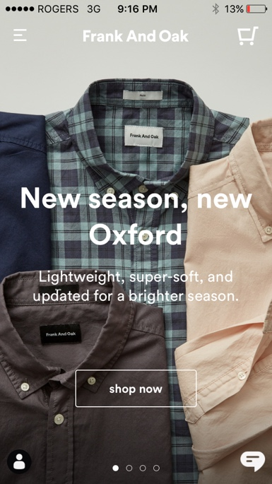The third channel utilized for the Frank & Oak customer experience is their app. Launched in 2013, not long after their opening, the app design flows seamlessly along with their store front and existing website. It has created further opportunity for touchpoints including in-store self-help, texting options, style updates, past purchases, and more. The app also allows users to access their blogs and lifestyle magazines to provide a more well-rounded experience, and to keep users engaged in their activities, not just their shopping optimization abilities.

This app has been a large part of their “before shopping” touchpoints as it optimizes push notifications, promotions, savings, and other incentives. Additional thouchpoint opportunities arise in the app through a social media type spin where consumers can “like” items of clothing instead of just adding it to their shopping cart. These unique additions have had a large effect on their purchasing statistics of their app, showing that 11% of purchases are from a result of this.

## Touchpoints

Frank & Oak has revolutionized the customer experience through a seamless transition of shopping and support channels. These channels have inundated the shopping experience with personalized touch points, allowing individuals to feel special and catered to. Below are just a few of the touch points we experience as customers. I will elaborate on what I consider the top three touch points, one from each category of before, during, and after shopping, based on how unique I felt they were to the brand.

The first touch point is word of mouth. Frank & Oak has really tapped into the marketing ability of word of mouth. They have created incredibly unique experiences that go beyond shopping including in store barber shops and “at home dressing rooms”. These “wow” factors have really pushed people to talk about their experiences that surpass the expected and have painted Frank & Oak in a light as a trendy thing to do, not just a trendy thing to buy. These experiences are the ones that fuel word of mouth campaigns.

The second touch point is the loyalty program. As I discussed earlier, this touch point is one of the most innovative designs gapping the bridge of online shopping and in-store activities. Customers engage with a virtual stylist through both online methods and when their package arrives. This touch point allows for individualization to cater to each person and allow them to feel special. This touch point is what the whole business has been created around. The other touch points in the “during shopping” category are just as important as they all work together to create this positive feeling for the customers.

The third touch point I believe to be important is one that happens after shopping and this is the follow up. Frank & Oak do a decent job of following up through expressing customer appreciation when they send billing and when they provide discounts after shopping, however they do not have the “wow” factor in their after shopping experience. In their pre- shopping experience, there is a grandeur and almost awe in the word of mouth campaigns. In the shopping experience, people are wowed by the innovative loyalty program. In the after shopping experience, the follow-up lacks a wow factor that meets the client’s needs or expectations of a personalized shopping experience. Without this third touch point being immaculate, they lose the ability to be a triple threat in their touch point success rates.

Figure 1: Frank & Oak Touchpoints

|  |  |  |
| --- | --- | --- |
| **Before Shopping** | **During Shopping** | **After Shopping** |
| Social Media | In app self- help services | Services and support teams |
| Advertising | Store Personnel/ Face2face | Billing |
| Ratings and reviews | Website Chat | Online help center |
| Word of mouth | Loyalty program | Follow ups |

## Further Analysis

### Design

Frank & Oak have created a modern brand that is trendy but approachable. Their channels and touch points reflect this. Their logo is clean cut but unique and interesting where individuals can recognize it. Their channels are similar in their modern and clean look with the use of oranges, browns, and yellows to create a warm and inviting feeling. Their website and app are designed in a way that mimic each other in visual hierarchy. For example, both chat options are located at the bottom right of the page, both shopping carts are at the top right, their order of title and information both start at the top left and move down in the same way. All of their channels, including their brick and mortar locations are well balanced in their visual weight, utilizing the white space they have available to them and placing their visual hierarchy in a modern way. They use grids to divide up their spaces to make sense and the grids flow seamlessly across channels. These design details of uniformity allow the uniqueness of the touch points and services being provided, to shine.

### Suggested Improvements

As noted in some of the previous sections above, there are some areas of improvement I believe Frank & Oak could introduce:

1. To create a fully holistic and well-rounded experience, they need to generate a follow-up experience, not just a thank you or discount. It should provide a wow factor, similarly to the rest of the CX encounters.
2. They should create an arrival experience at their brick and mortar locations to reflect the effortlessness of their online experience. Although the barber shop does touch on this, I have found it is the simple things that make my experience better such as better access to parking, or even a customized greeting at the door upon arrival.

Frank & Oak have created a brand that is unique, innovative, seamless across all channels, and tailors to individual needs. They are a company who has rapidly expanded across their customer and fan base since 2012 and are a leader in the new technology and fast fashion industry. Their branding is recognizable across Canada and has been well crafted on all platforms. As the industry continues its rapid development however, even Frank & Oak will need to improve and innovate past what they are now. Who knows, maybe these suggestions may be implemented in their future design development.

## References

Frank & Oak. (n.d.). Retrieved February 28, 2018, from https://www.blogto.com/fashion/frank-and-oak-toronto/

How to identify your customer touchpoints. (n.d.). Retrieved February 28, 2018, from <https://www.surveymonkey.com/mp/identify-customer-touchpoints/>

Touchpoints key to retail success. (n.d.). Retrieved February 28, 2018, from https://retailnext.net/en/blog/touchpoints-key-retail-success/